**SALESFORCE-SUPPORTED VIRTUAL INTERNSHIP PROGRAM 2025**

**PROJECT:** REPLASTIC INNOVATIONS:TRANSFORMING PLASTIC WASTE INTO SUSTAINABLE SOLUTIONS

**NAME :** S Pavan Vamsi Krishna

**DEPARTMENT :** CSE

**COLLEGE NAME :** SRM UNIVERSITY,AP

**COLLEGE MAIL:** [**pavanvamsikrishna_siraparapu@srmap.edu.in**](mailto:pavanvamsikrishna_siraparapu@srmap.edu.in)

**TRAILBLAZER LINK:** <https://www.salesforce.com/trailblazer/ul0hyzomqpndlf1vwe>

**DATE:**24/07/2025

**Acknowledgement :**

I would like to express my sincere gratitude to **Salesforce** for providing me with the opportunity to undertake this project. The experience has significantly contributed to my understanding of cloud-based solutions and their role in addressing real-world challenges.

I extend my heartfelt thanks to my mentor and the Salesforce Trailhead community for their consistent guidance and technical support throughout the development process. Their expertise and feedback were instrumental in the successful completion of this project.

I am also thankful to all individuals who provided encouragement and support during this learning journey.

# Project Overview :

The project **“RePlastix Innovations – A Salesforce-Driven Approach to Sustainable Plastic Recycling”** focuses on transforming the plastic waste recycling process through Salesforce automation. The aim is to enhance operational efficiency, ensure better resource tracking, and promote environmental sustainability using cloud-based tools.

This system automates key functions like waste collection, inventory management, restock handling, and order processing. It utilizes Salesforce features such as custom objects, flows, Apex classes, validation rules, and dashboards to enable real-time monitoring, role-based access, and seamless communication between departments.

By integrating business logic with automation, the solution ensures timely restocking, accurate stock updates, and task assignments. The project demonstrates how Salesforce can go beyond CRM to address real-world challenges, supporting both operational and environmental goals in a structured and scalable way.

# Objectives:

The objective of this project is to automate the plastic recycling process using Salesforce to improve efficiency, ensure real-time monitoring, and support sustainability. The system is designed to simplify operations like waste tracking, inventory updates, and order handling through custom Salesforce tools.

**Key Objectives:**

* Automate plastic waste collection, stock tracking, and order processing.
* Enable real-time inventory alerts for low stock.
* Create custom objects for waste, products, orders, and restocks.
* Use validation rules and formulas to ensure data accuracy.
* Provide role-based access with proper profiles and sharing rules.
* Send automated email notifications on restock approval.
* Build a centralized Lightning App for user-friendly access.
* Track performance using reports and dashboards.
* Test automation with Apex test classes for full coverage.
* Ensure future readiness with scope for chatbot and API integration.

**Technology Description**

The project is developed using **Salesforce**, a cloud-based platform known for its scalability, automation, and low-code capabilities. It provides the tools needed to build custom applications that meet business-specific needs without requiring heavy development.

**Tools & Components Used :**

* **Custom Objects** – Created for Plastic Waste, Recycling Centers, Recycled Products, Orders, and Restock Requests to manage structured data.
* **Lightning App Builder** – Designed a unified application interface for smooth navigation and operations.
* **Profiles and Roles** – Defined to control user access and maintain data security.
* **Flow Builder** – Used to schedule daily checks and automate inventory alerts.
* **Apex Classes & Triggers** – Implemented to automate stock updates and create restock requests.
* **Validation Rules & Formula Fields** – Ensured data accuracy and triggered condition-based actions.
* **Reports & Dashboards** – Enabled performance tracking and informed decision-making.

Salesforce’s combination of declarative tools and programmatic features helped build a flexible, automated solution that supports sustainable waste management practices.

**Detailed Execution of Project :**

This project was executed in well-defined phases using the Salesforce platform. Each phase involved specific tools and features that contributed to building an efficient and scalable plastic recycling management system. Below is a step-by-step explanation of how each part was implemented.

1. **Developer Org Setup**  
   A Salesforce Developer Org was created using [developer.salesforce.com](https://developer.salesforce.com). This provided a personal development environment to safely build and test the application without affecting any production data. All setup, configurations, and customizations were done here, including enabling API access and developer tools

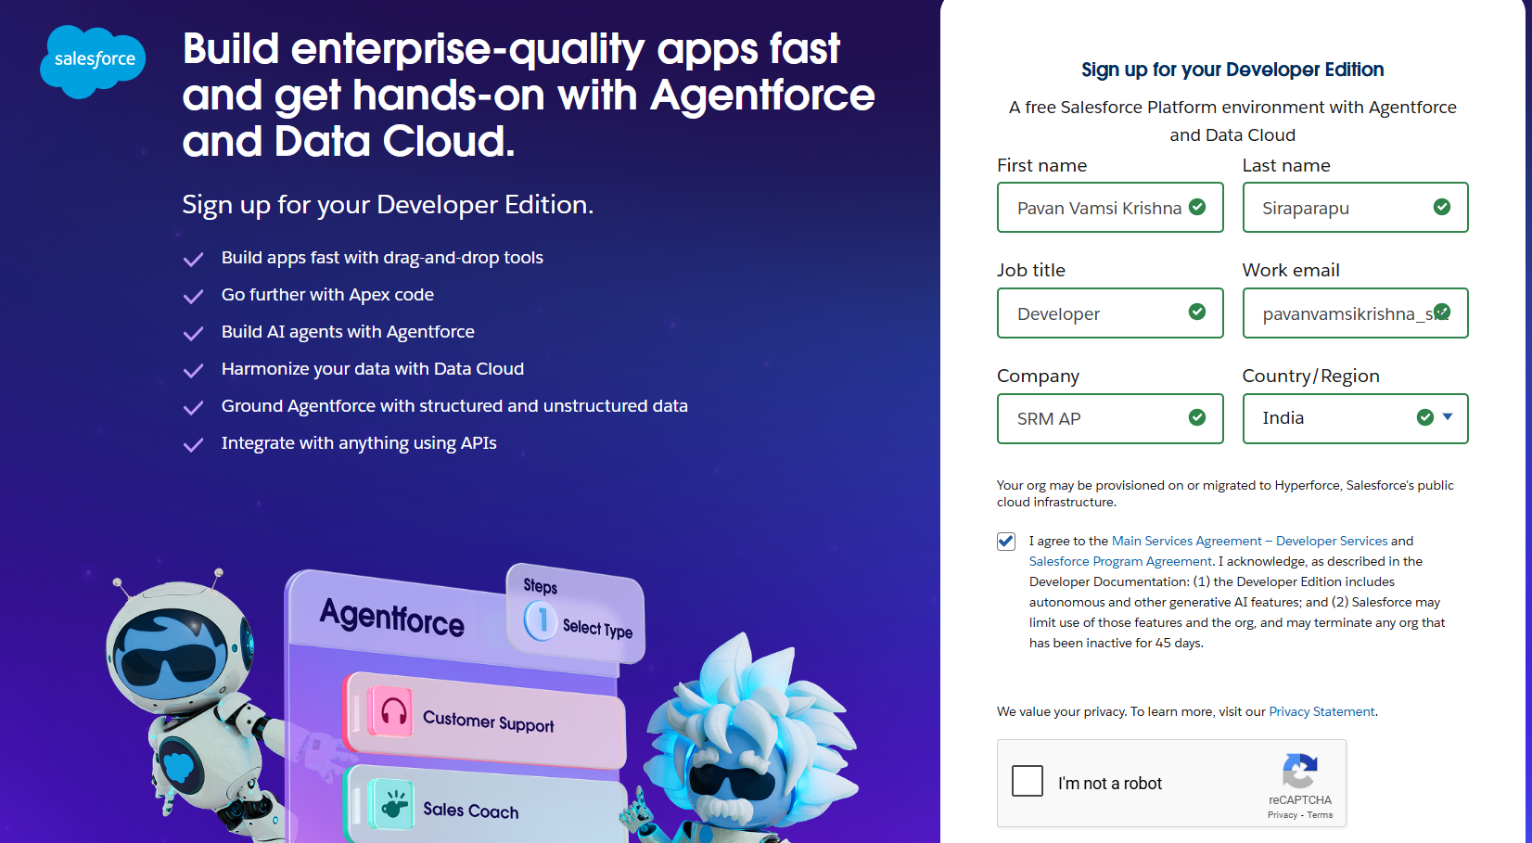.

**2. Custom Object Creation**  
Five custom objects were designed to represent real-world business operations in the recycling workflow. Each object includes multiple fields tailored to specific requirements.

* **Plastic Waste** – Tracks the type of plastic (e.g., PET, HDPE), its weight, location of collection, collection date, and current processing status.
* **Recycling Center** – Records the name, address, and maximum capacity of recycling units.
* **Recycled Product** – Manages stock levels, price, reorder thresholds, and product category.
* **Order** – Handles orders from customers, including product type, quantity, and delivery schedule.
* **Restock Request** – Used by staff to request inventory replenishment when stock levels fall below the threshold.

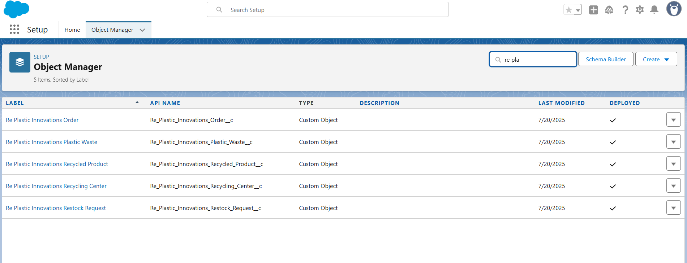

**3. Lightning App Setup**

A custom **Lightning App** titled *“RePlastix Innovations”* was created using the Lightning App Builder. This app includes tabs for each of the custom objects and allows users to interact with all relevant data from a single, user-friendly interface. Custom page layouts and compact layouts were also configured for better usability and quick record insis.

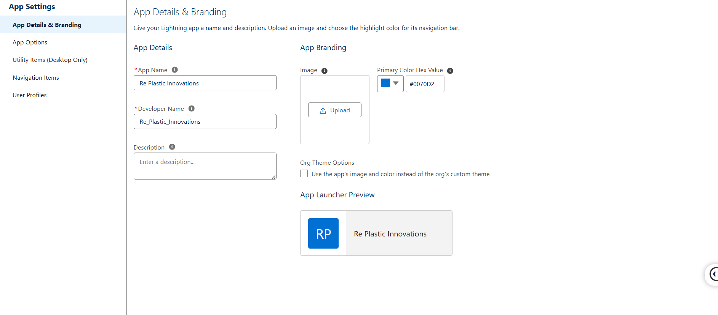

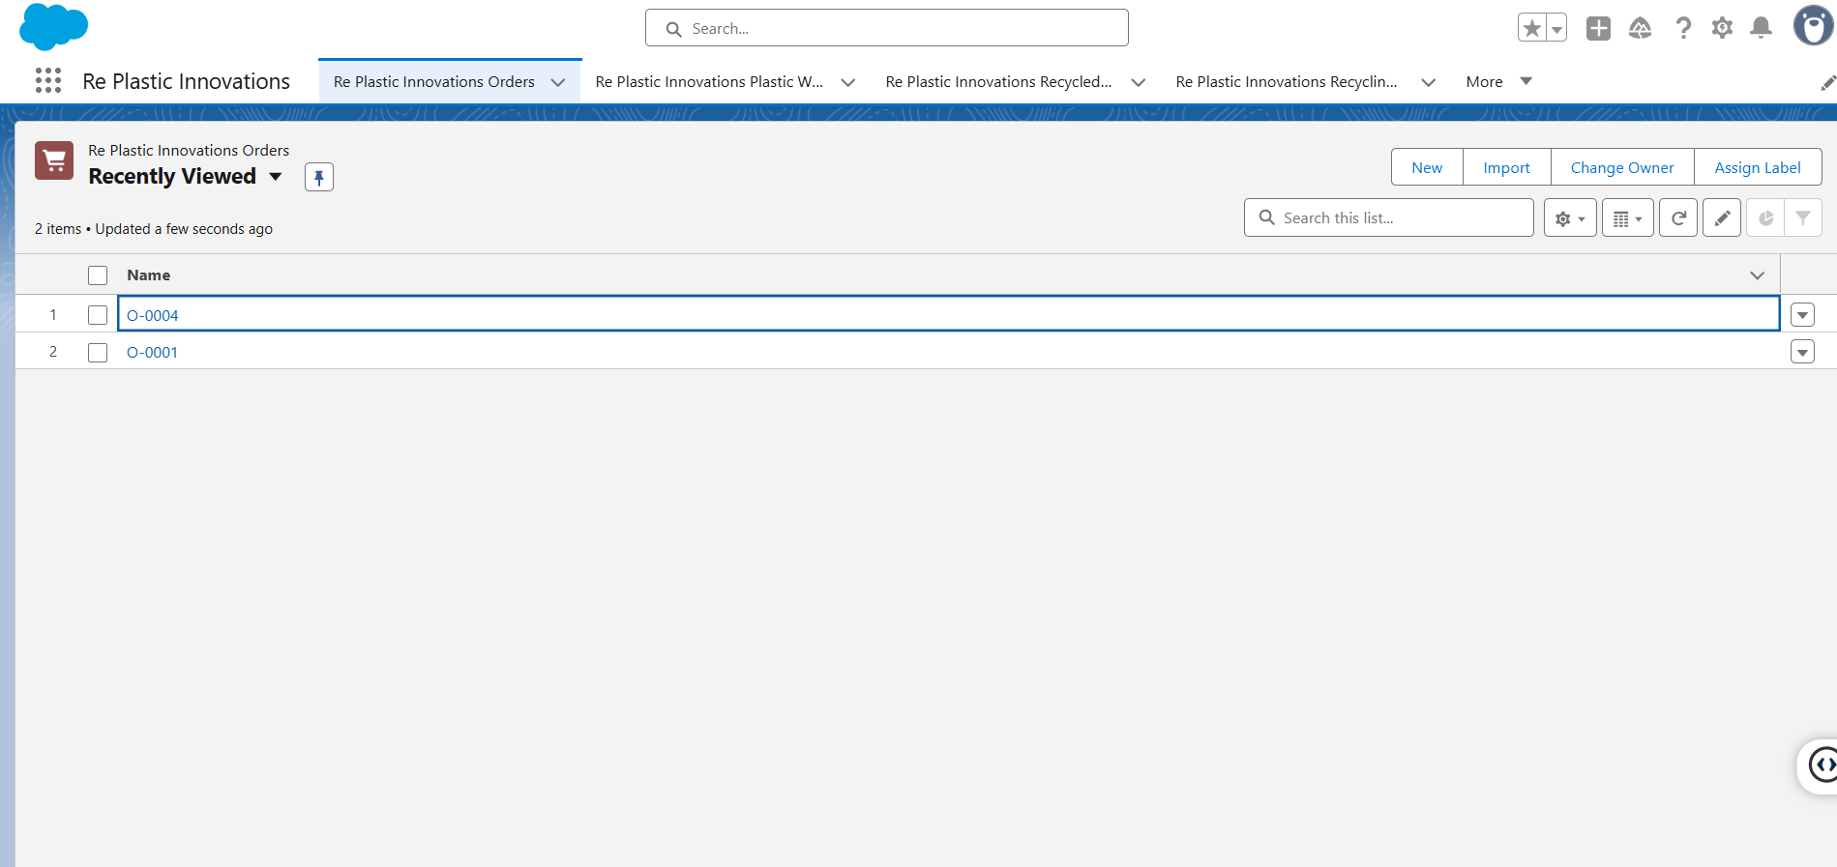

**4. Tabs, Roles, and Profiles**  
Tabs were created for each object and added to the app navigation.

* **Roles** were structured hierarchically: CEO (top-level), Sales Representative (mid-level), and Warehouse Supervisor (operational level).
* **Profiles** were created to assign specific permissions. For example:
  + Platform User 1: Read and create access for Plastic Waste and Restock Requests.
  + Platform User 2: Access to Orders and Account details.
  + Platform User 3: Full access to all objects for admin tasks.

This structure helps maintain both security and operational efficiency.

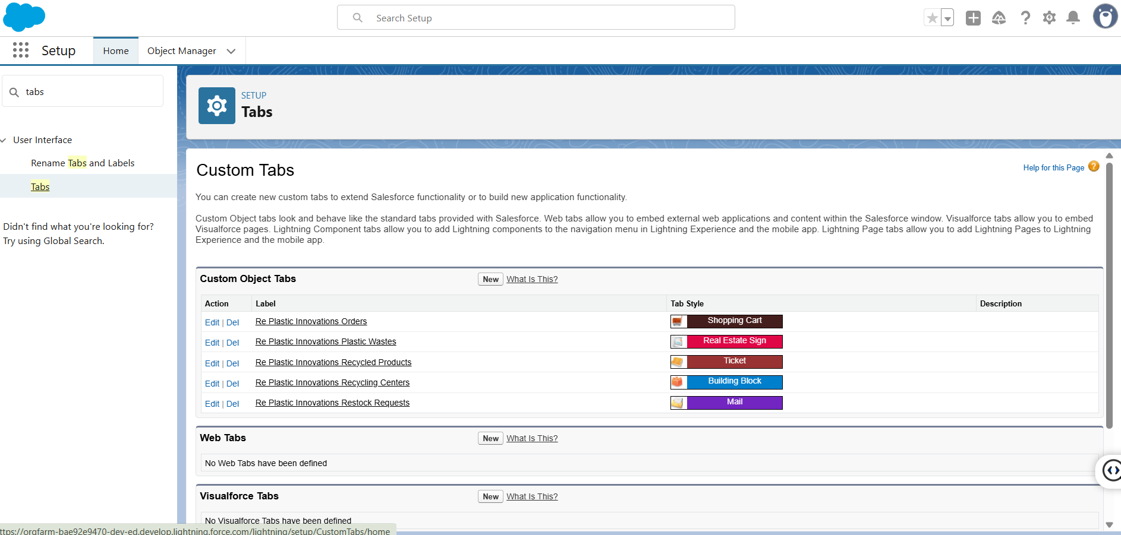

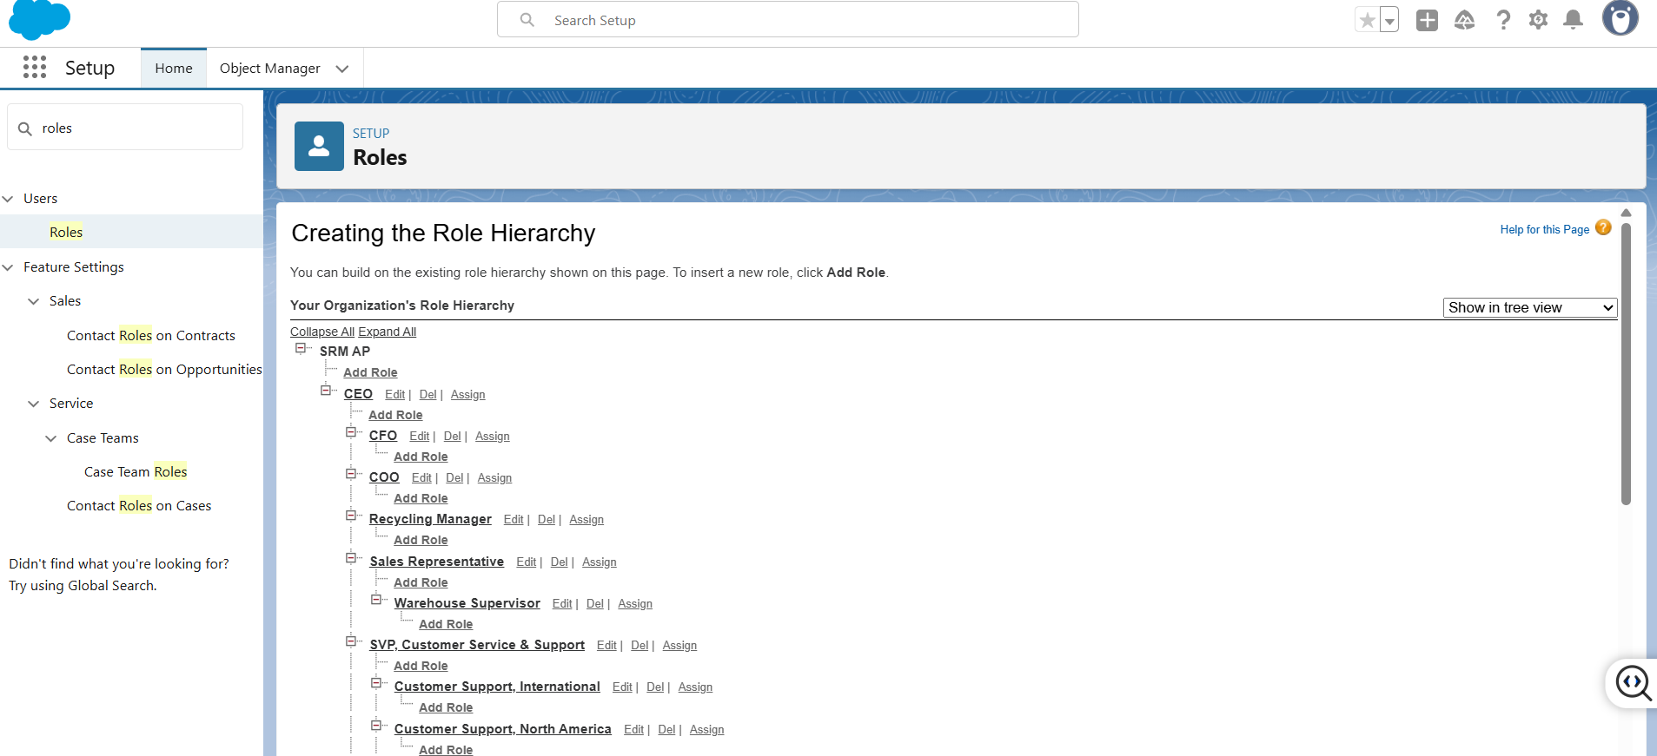

**5. User Creation**  
Three sample users were created to simulate different roles within the organization:

* **John (Recycling Manager)** – Oversees the recycling process and manages plastic waste records.
* **Mike (Sales Representative)** – Handles customer orders and tracks order fulfillment.
* **Albert (Warehouse Supervisor)** – Manages inventory levels and processes restock requests.

Each user was assigned the correct role and profile to reflect real-world responsibilities and access levels.

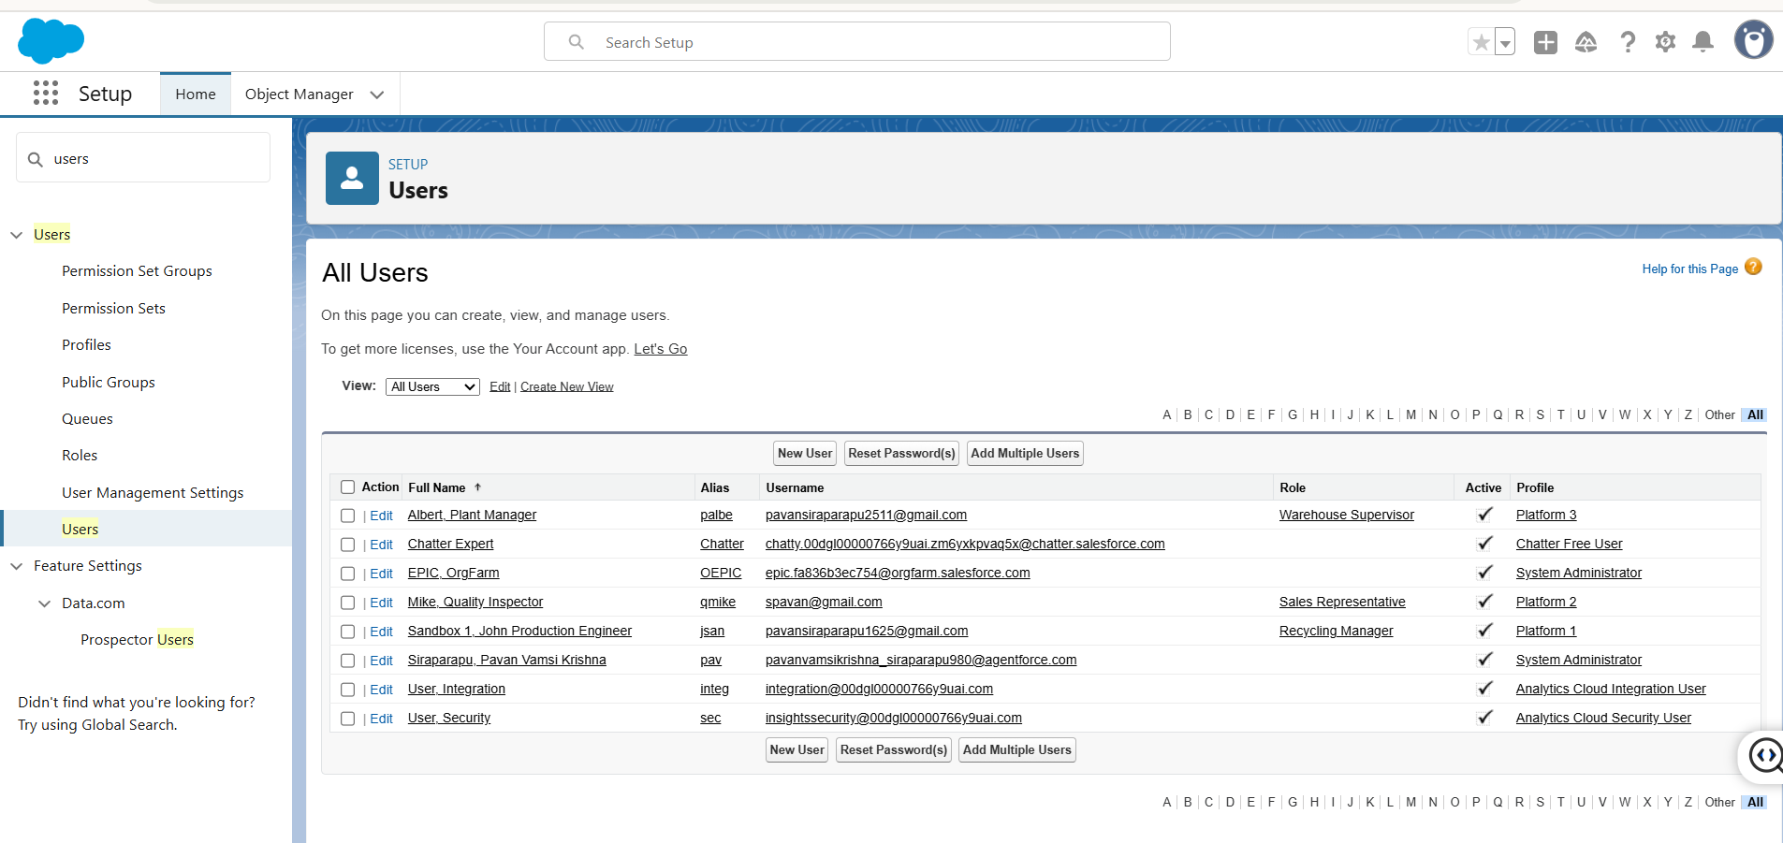

**6. Sharing Rules**  
To control access at the record level, **Sharing Rules** were implemented.

* CEO can view all Plastic Waste and Recycled Product records for overall monitoring.
* Sales Rep can access only the records required for processing customer orders.
* Warehouse Supervisor is limited to stock and restocking data.  
  This ensures sensitive data is visible only to authorized personnel, improving security and compliance.

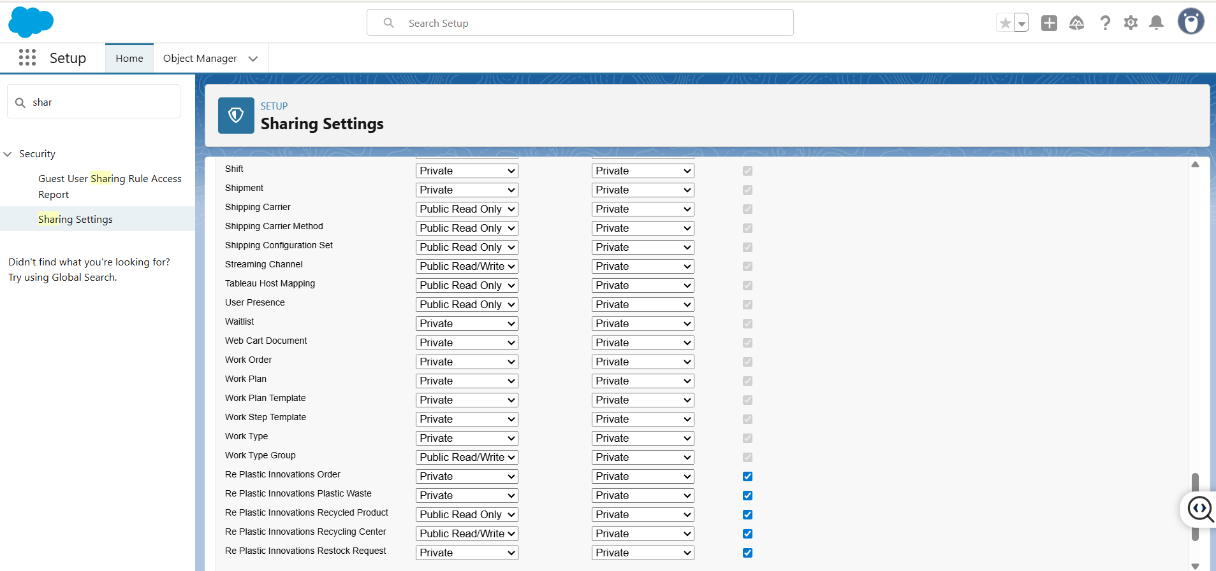

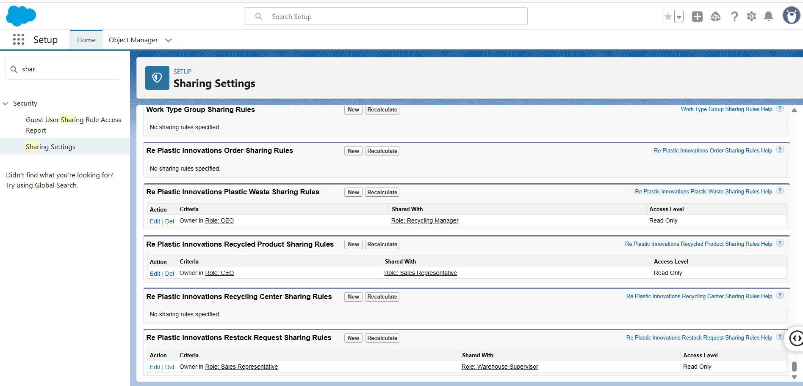

**7. Formula Fields**  
A custom **Formula Field** named *“Stock Low On Product”* was created under the Recycled Product object. It automatically checks if the stock is below the threshold and displays:

**"Low Stock - Restock Needed" or "Sufficient Stock"**

This gives users instant visibility of stock status without manual calculations, improving decision-making.

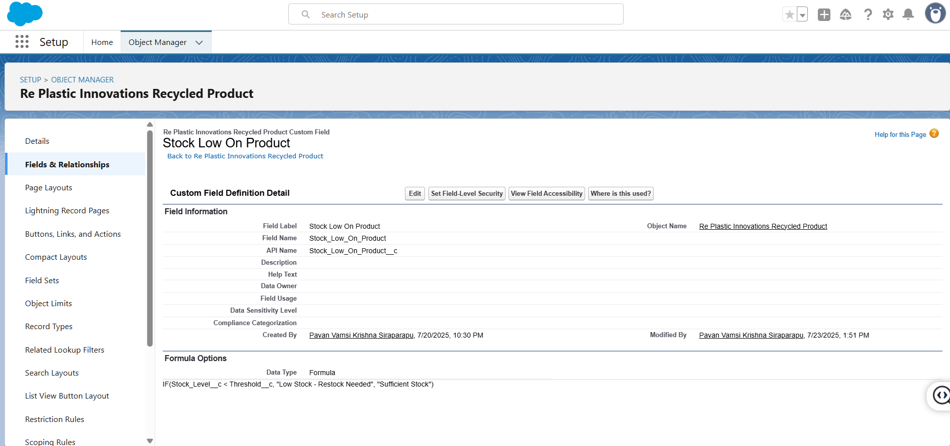

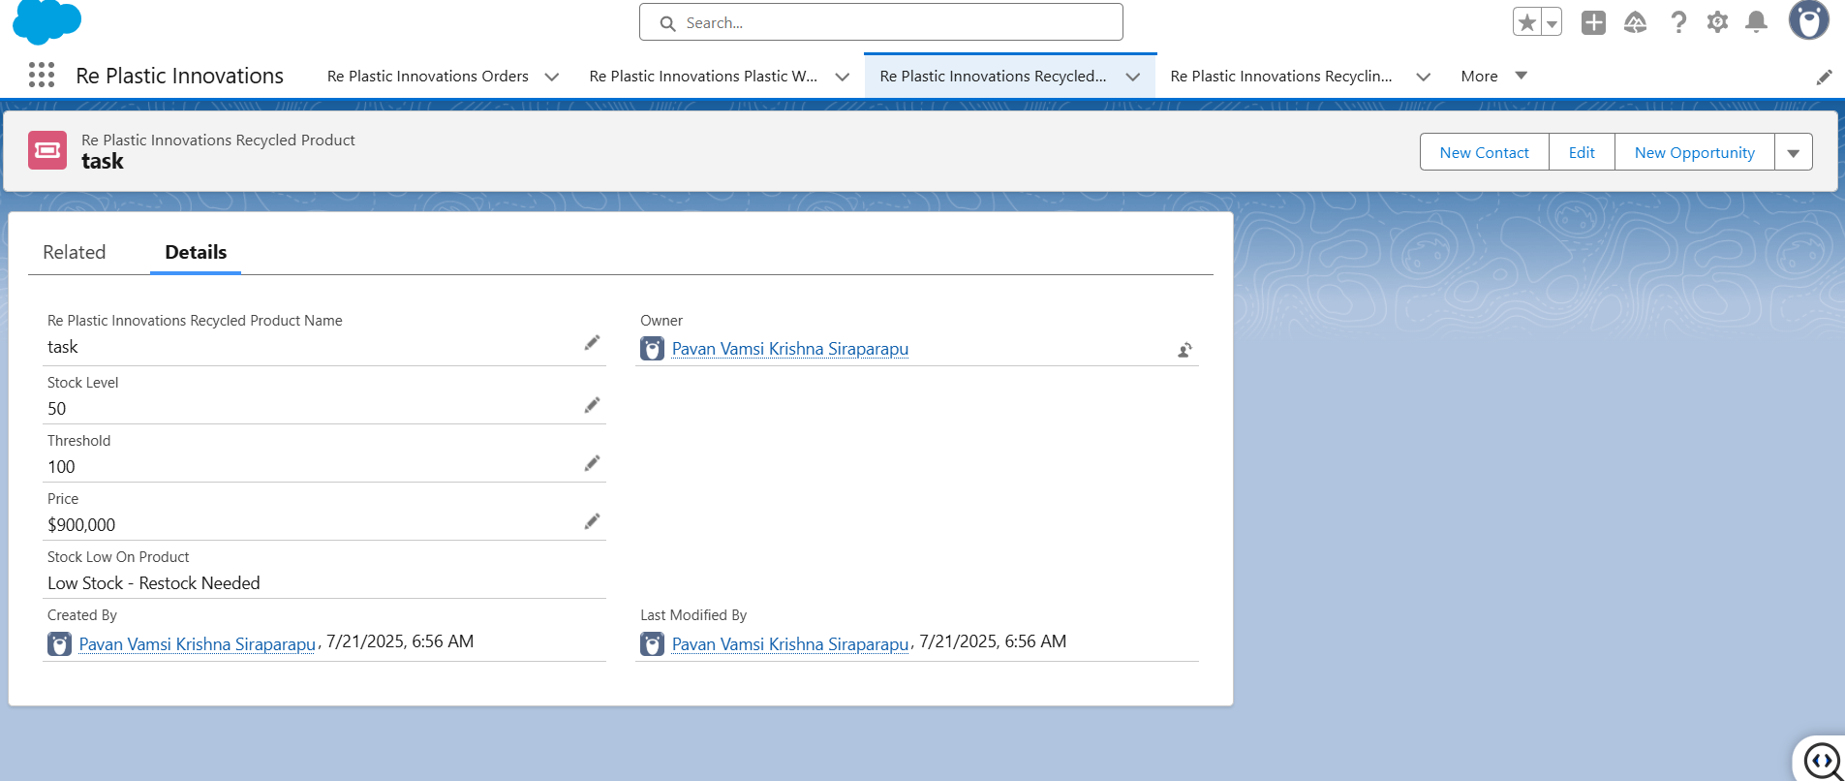

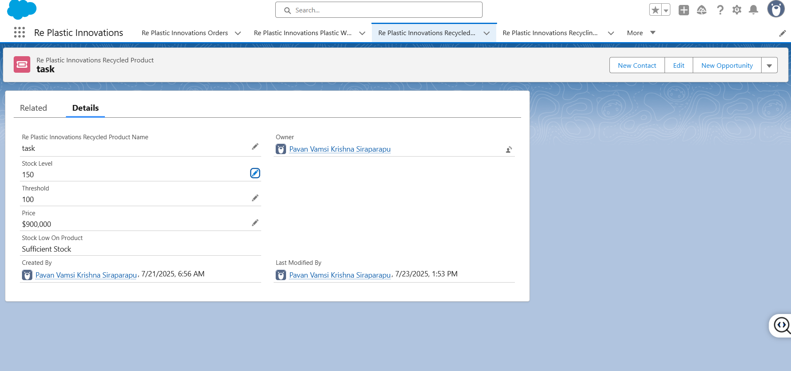

**8. Flow Builder**  
A **Scheduled Flow** was built using Flow Builder. It runs daily at **6:00 AM** and performs the following:

* Checks each Recycled Product to see if its stock level is below the threshold.
* If true, it creates a task automatically and assigns it to the responsible user with the subject *“Stock is Low”*.
* The task status is set to *In Progress*, reminding the user to act.

This automation ensures stock monitoring happens regularly without manual effort.

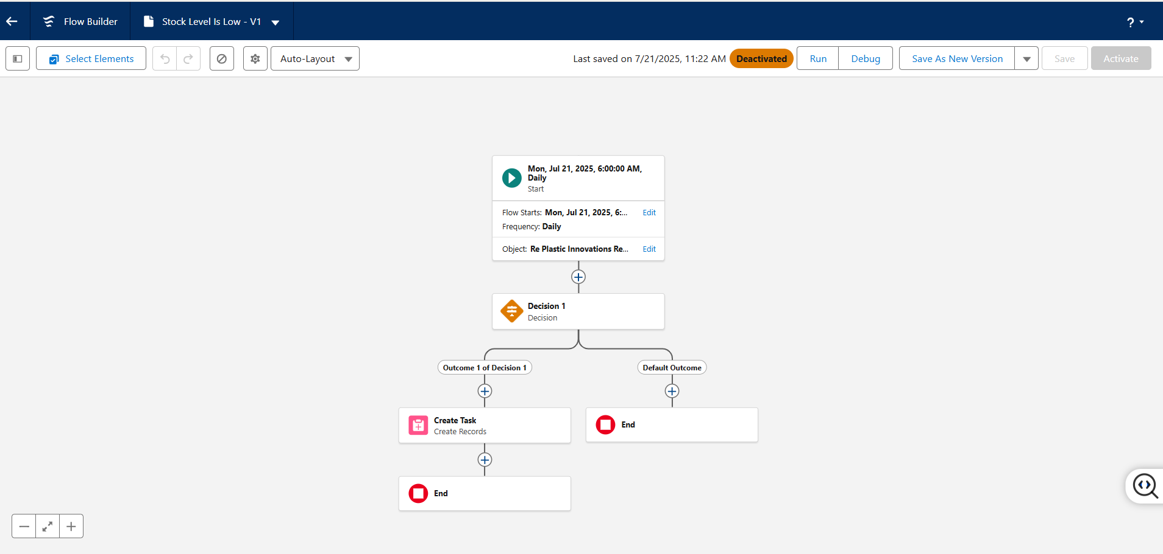

**09. Apex Classes & Triggers**  
An **Apex Class** named InventoryManager was developed for backend logic:

* When an order is placed, the class automatically deducts the ordered quantity from the product’s stock.
* If the remaining stock is below the threshold, it creates a new restock request.
* Once a restock request is approved, the stock is updated accordingly.

**Triggers** were added:

* UpdateStockAfterOrder: Executes after an order is inserted.
* UpdateStockAfterRestockApproval: Executes when a restock request is approved.

This ensures full automation of inventory control with no need for manual updates.

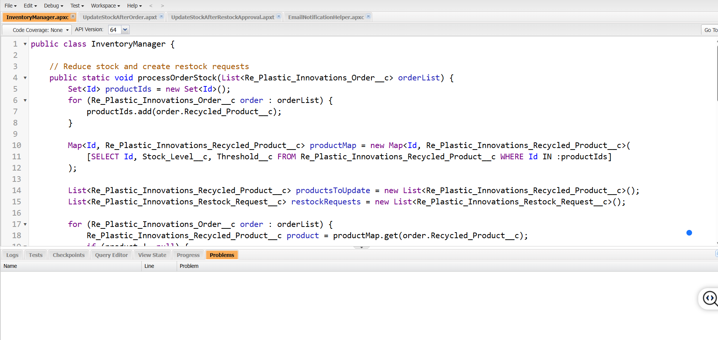

**10. Testing**  
To validate all logic, a test class InventoryManagerTest was written. It simulates:

* Order creation and corresponding stock deduction.
* Restock request approval and stock replenishment.  
  This class ensured **100% code coverage**, verifying that the automation logic is reliable and safe for production.

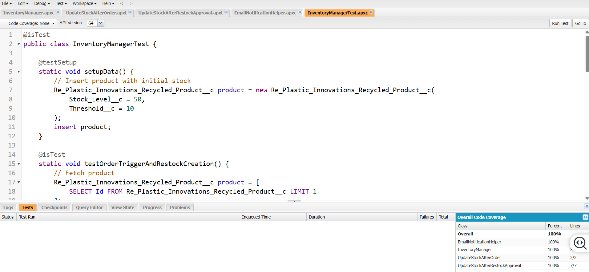

**Conclusion :**

The project **“RePlastix Innovations – A Salesforce-Driven Approach to Sustainable Plastic Recycling”** successfully demonstrates how Salesforce can be used to automate and manage plastic waste recycling processes. By using Salesforce features such as custom objects, flows, Apex classes, dashboards, and validation rules, the system ensures real-time tracking, efficient stock management, and secure user access.

The solution improves operational workflows by reducing manual tasks, providing low-stock alerts, automating restock requests, and enhancing communication through email notifications. It also supports better decision-making with data-driven reports and dashboards. Overall, the project highlights the potential of cloud platforms like Salesforce to address real-world environmental challenges through technology.

**Future Scope :**

The system can be further improved and scaled with the following enhancements:

* **Chatbot Integration**: Implement a Salesforce chatbot to provide real-time support, updates, and user interaction.
* **AI-Based Forecasting**: Use AI to predict future stock requirements based on past usage trends.
* **Mobile App Development**: Create a mobile version for field staff to update records and track status on the go.
* **Third-Party API Integration**: Connect with logistics partners or external CRMs for a complete supply chain view.
* **Barcode/QR Integration**: Add barcode scanning for faster product identification and inventory updates.
* **Multi-Center Support**: Extend the system to manage multiple recycling centers across different locations.

These additions will make the system more intelligent, accessible, and scalable for large-scale use.

**THANK YOU**

|  |
| --- |
|  |
|  |  |